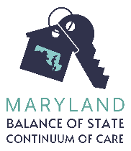
Maryland Balance of State Continuum of Care
Coordinated Entry System
Domestic Violence Certification

Client Self Certification

I certify that (must meet all 3 requirements):
- I am fleeing or attempting to flee domestic violence,
- I have no subsequent residence to go to, and
- I lack the financial resources and/or support network to obtain a residence.
Client name (print clearly)
Client signature
Date

Provider Certification

To the best of my knowledge and based on my professional judgment, the client named on this form is currently fleeing or attempting to flee domestic violence, has no subsequent residence to go to, and lacks the financial resources and/or support network to obtain a residence.

Agency
Name of intake worker
Signature of intake worker

Required for all providers:
Where the safety of the client is not jeopardized, the caseworker must take steps to verify the above statement by obtaining (1) third party verification from a services provider, a copy of a police report, or other documentation showing the client is fleeing or attempting to flee domestic violence, as well as (2) documentation of the client’s lack of resources to obtain housing (e.g. income documentation). Please initial below to indicate:

_______This documentation is attached, OR

_______This documentation could not be obtained. Instead, I have attached documentation summarizing my attempts to obtain 3rd party documentation and what (if any) other evidence I have that leads me to believe the client’s statements are true (e.g. observations about the client’s presentation, services participation, etc.)

