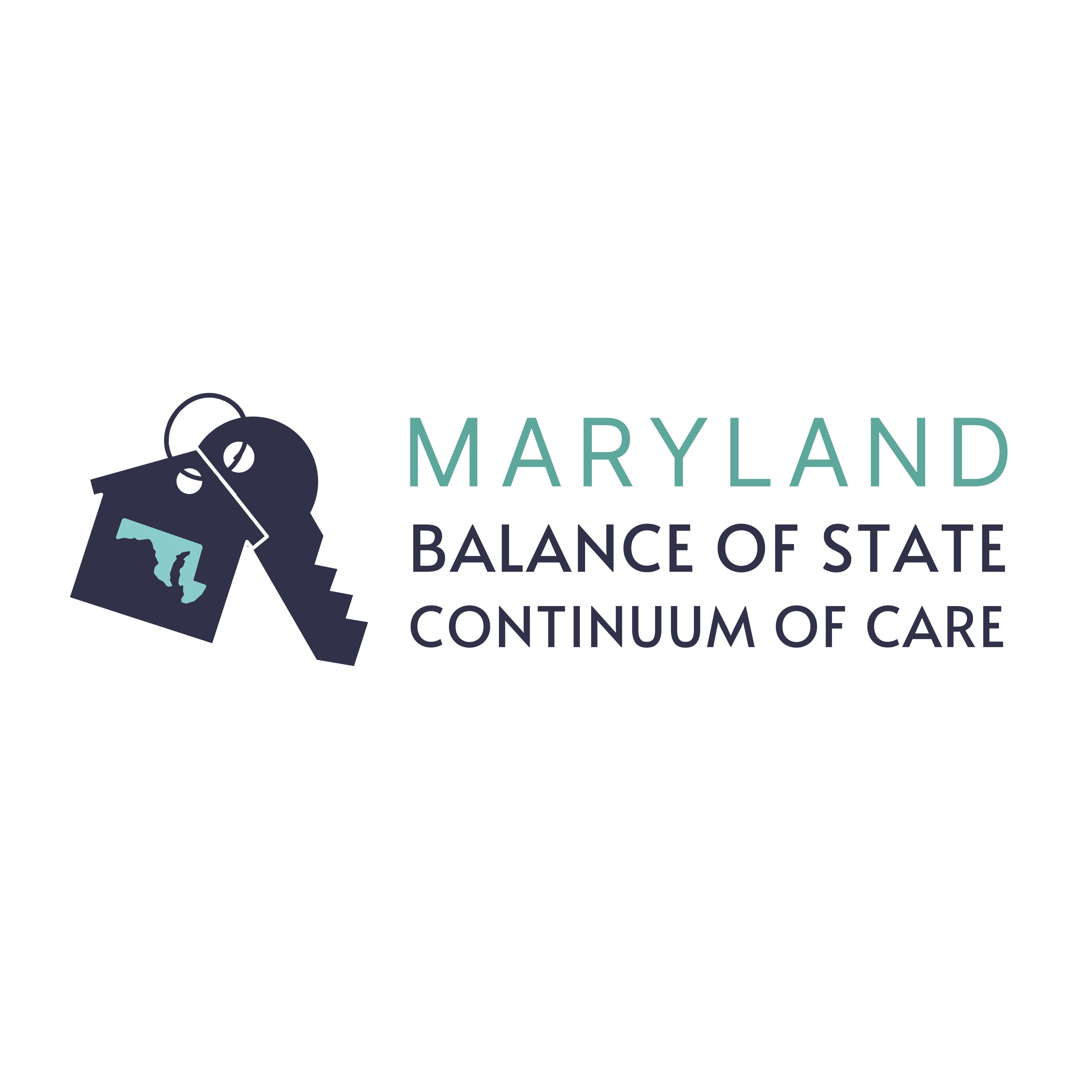
Performance Review Committee Instructions
The Performance Review Committee is provided with basic tools to aid in the ranking process for FY2024 Continuum of Care Funding.
- CoC Policies, Program Information, Document Templates
- New Project Applications, New Project Scoring Sheet & Feedback Form
- Renewal Project Scores (pre-scored by DHCD)

Project Review Steps:
- Review the Posted CoC Documents: The FY2024 Competition Policy Guide, BoS Request for Proposals and CoC Glossary provide basic information regarding the competition and additional guidance on project review.
  - The project ranking policy (page 18) & the reallocation policy (page 16) (within the Competition Policy Guide) will be used in to finalize the funding recommendation at the next meeting.

- Review Each New Project Application: All new project applicants have submitted a response to the Balance of State Request for Proposals which includes a series of narrative responses and required documentation.
  - Each new project has an accompanying Application (RFP) and Scoresheet. DHCD has pre-scored any elements that do not need additional review (ex: timely submission, inclusion of requested policies, etc).
  - Additional pages for unanswered questions, etc. have been removed from the PDF to simplify the scoring process for the reviewer but can be provided upon request.
  - Record project scores on the accompanying scoring tool for each project and make any notes for feedback that should be provided to the applicant, if necessary. All project feedback will be anonymous.
Airtable Site: Application & Scoring Tool Notes
- From the “New Project Applications 2024” screen on the BoS website, you can click “View Larger Version” at the bottom of the grid to see the full page
- Each individual RFP (or other uploaded documents) can be printed or downloaded by clicking on the relevant button on the document preview screen
- On the Scoring Tool, please enter a score in every required field, you may enter “0” if the response is blank or insufficient
- Once you hit “Submit” for each scoring tool, you will receive an email that includes just your scores for each question, you can keep these emails as a reminder of how you scored each project
- If you need to change a score on a previously scored application, you’ll need to complete a new scoring tool
  - We have the submissions time-stamped, so we’ll know which response is the most current
  - Tip: Consider reading through each RFP before you start to score so you can have an idea how they compare – this might reduce the need to make revisions to scores

- Review the Renewal Project Scores: Each renewing project has a Project Score Card. The score cards have been pre-scored by DHCD based on project performance from the prior year. Review the metrics and total score as well as any comment provided by the agency (which may explain any unusually high or low scores). The Project Score Card will not need additional scoring. However, you may bring any areas of concern for discussion to the next meeting since all projects are subject to priority ranking and reallocation.

- Return Project Scores and Any Comments to DHCD by October 3, 2024. Each reviewer will submit 11 scoresheets, (1 per new project application) along with any additional comments and feedback for the applicant.

- Attend the Performance Review Committee Meeting on October 4, 2024: The committee will review project applications, discuss any concerns, finalize the project ranking and make final funding recommendations. If you are unable to attend on the 4th, please still send all scores and any additional comments regarding funding decisions and/or reductions that will be included in the discussion.

